To do this create an extension with the same number as the trunk:



Set the trunk with the following:

Username = number allocated on the Samsung also same as the one in extension see above.

Password = the password for Samsung

Host = Samsung IP

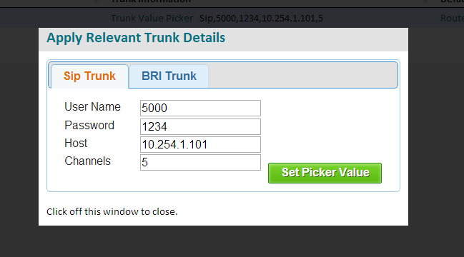

In routing select the dialplan fallthrough:

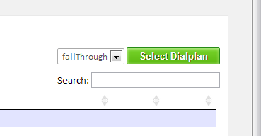

Create a route as follows:

Dialed Number = Any

Destination = AddCode 5 for 0

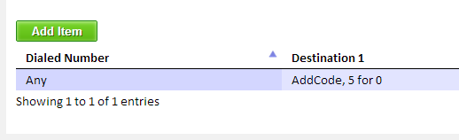

By keeping the extension in if the system goes down it will reregister ok.

FTW!